AUTOMATED STREET LIGHT USING IR SENSORS AND LIGHT DEPENDENT RESISTOR

submitted by :

sauhard, 18105022

kshitij parashar, 18105035

Gagandeep Chauhan, 18105023

[Year]

The public wastage of resources is one the biggest concerns today. Governments of almost countries are trying to figure out ways to handle this situation. To prevent the wastage of electricity we have brought a solution that can be implemented to the street lights which will reduce the consumption of electricity and save energy.

**COMPONENTS USED**

* 9V Battery
* Light Dependent Resistor
* BC547
* IR Sensor Module
* LM339 Comparator IC
* 7408 AND Gate IC
* Resistor (43.5k, 1k(x2), 13.1)
* Potentiometer (10k)
* LED

Light Dependent Resistor – It is semiconductor device that exhibits photoconductivity. It is a light controlled variable resistor whose resistance decreases when intensity of incident light increases. It is used in the circuit to detect day and night.

BC547 – BC547 is a npn BJT mainly used for amplification and switching purposes. In the circuit, it is used as a switch(open during day and closed at night).

IR Sensor Module – IR sensor is used to detect the coming vehicles and gives high output when a vehicle is detected.

LM339 Comparator – Comparator is a device that compares two voltages and gives the output depending on which voltage out of the two is higher than other. It is used to convert low output from transistor to high output and vice-versa.

IC 7408 – It is an AND gate IC with four AND gates in it. It takes input from comparator and IR sensor and gives high output when both inputs are high.

**Circuit Diagram**

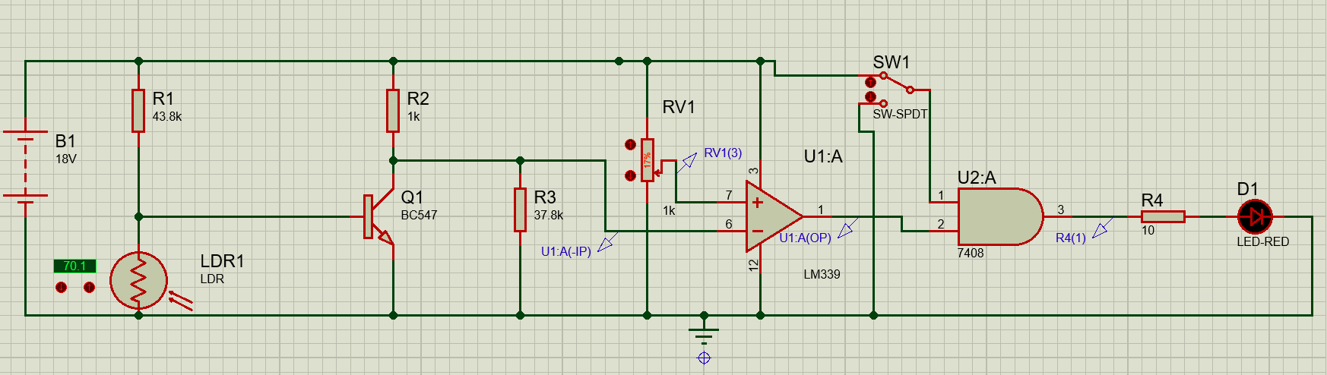

In the circuit diagram, a SPDT switch is shown in place of IR sensor.

**Working**

*During day* – During daytime, resistance of LDR decreases and transistor operates in cut-off(OFF) region. As the reference voltage of comparator is 2.15V and collector 2.41V, therefore comparator gives low output and the street light(LED) is off.

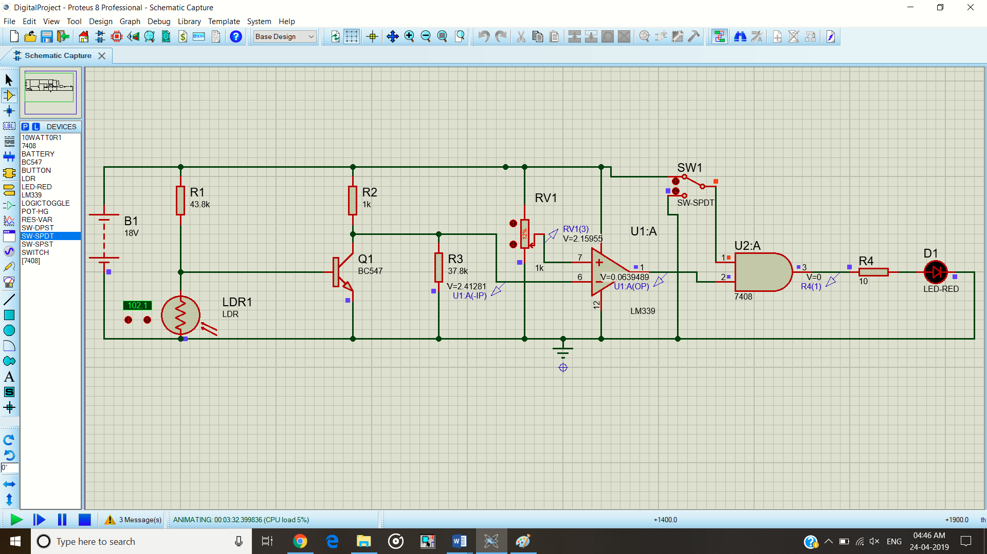

*At night and No traffic* – At night, resistance of LDR is high and transistor operates in saturation(ON) region. Therefore, collector voltage is 0.6V and since reference voltage at comparator is 2.15V, comparator gives high output. But the output of AND gate is low and street light(LED is OFF because the output of IR sensor is low as no vehicle is detected.

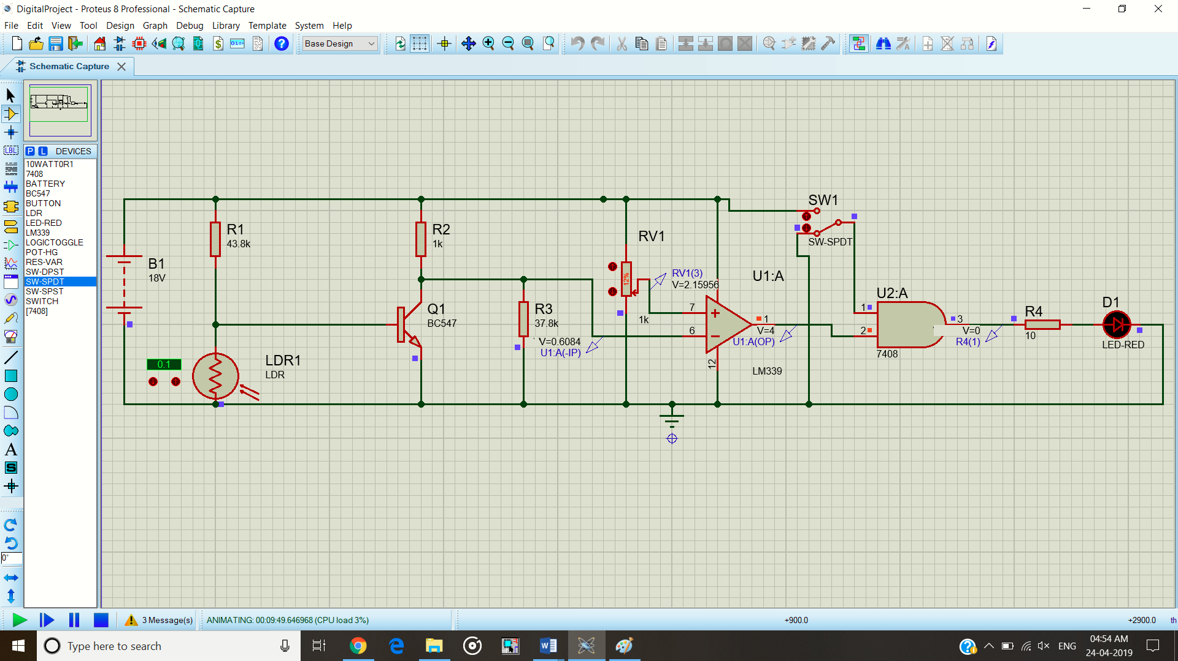

*At night and vehicle Detected* – At night, when a vehicle is detected, the output of IR sensor is high. Since the output of comparator is also high, the AND gate gives high output thus turning the street light(LED) ON.

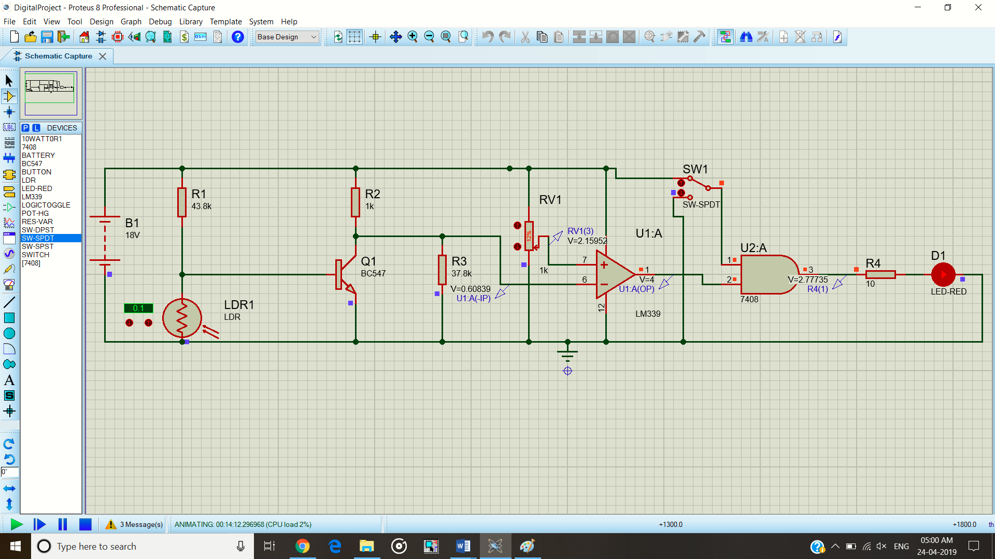

**Conclusion**

A model for automatic street light dependent on LDR and IR sensor was successfully developed.